MobSF (Budget App Analysis Write Up)

Introduction
This report outlines an evaluation of the Mobile Security Framework (MobSF), a tool considered for use by our security team. To test its effectiveness, a static analysis was performed on the "Budget Master" application. The framework provided a detailed and insightful overview of the app's security posture, ultimately demonstrating its value as an automated security analysis tool.

The MobSF scan immediately highlighted significant risks, assigning the application a low security score of 49 out of 100 and classifying it as a "MEDIUM RISK". The most critical findings were related to insecure build configurations. The analysis revealed that the application was signed with a debug certificate and that debugging was explicitly enabled (android:debuggable=true). These are high-severity vulnerabilities because they make it substantially easier for an attacker to reverse engineer, inspect, and tamper with the application. MobSF also identified several other important warnings. For instance, the tool flagged that application data can be backed up via adb, which could lead to sensitive user data being copied off a device. Furthermore, the scan uncovered potentially hardcoded secrets, including a Google API key, which presents a direct risk of credential compromise if the key is not properly restricted.

Conclusion
Based on its ability to quickly and accurately identify these fundamental security flaws, this report strongly supports the adoption of MobSF. The tool is highly effective at automating the initial phase of security assessment, providing clear, actionable intelligence that developers can use to remediate vulnerabilities. Its analysis is comprehensive, covering the application's manifest, code, and certificates to create a holistic security profile. By integrating MobSF into our development lifecycle, we can establish a crucial baseline for security, ensuring that common but critical misconfigurations are identified and resolved before applications are released. In conclusion, the evaluation confirms that MobSF is a valuable, efficient, and powerful tool that would significantly enhance our organization's mobile application security. We recommend its formal adoption into our security and development processes.

MobSF Dashboard:
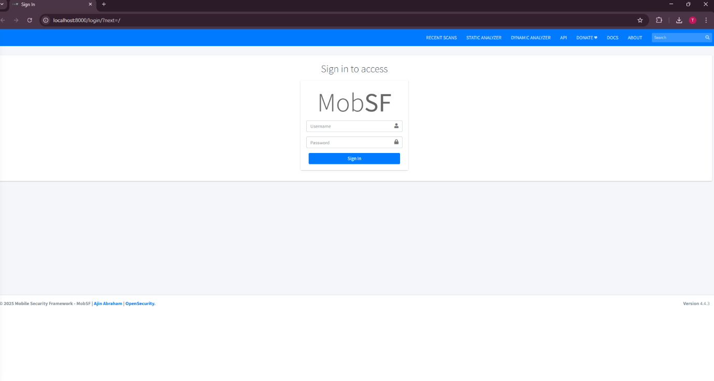

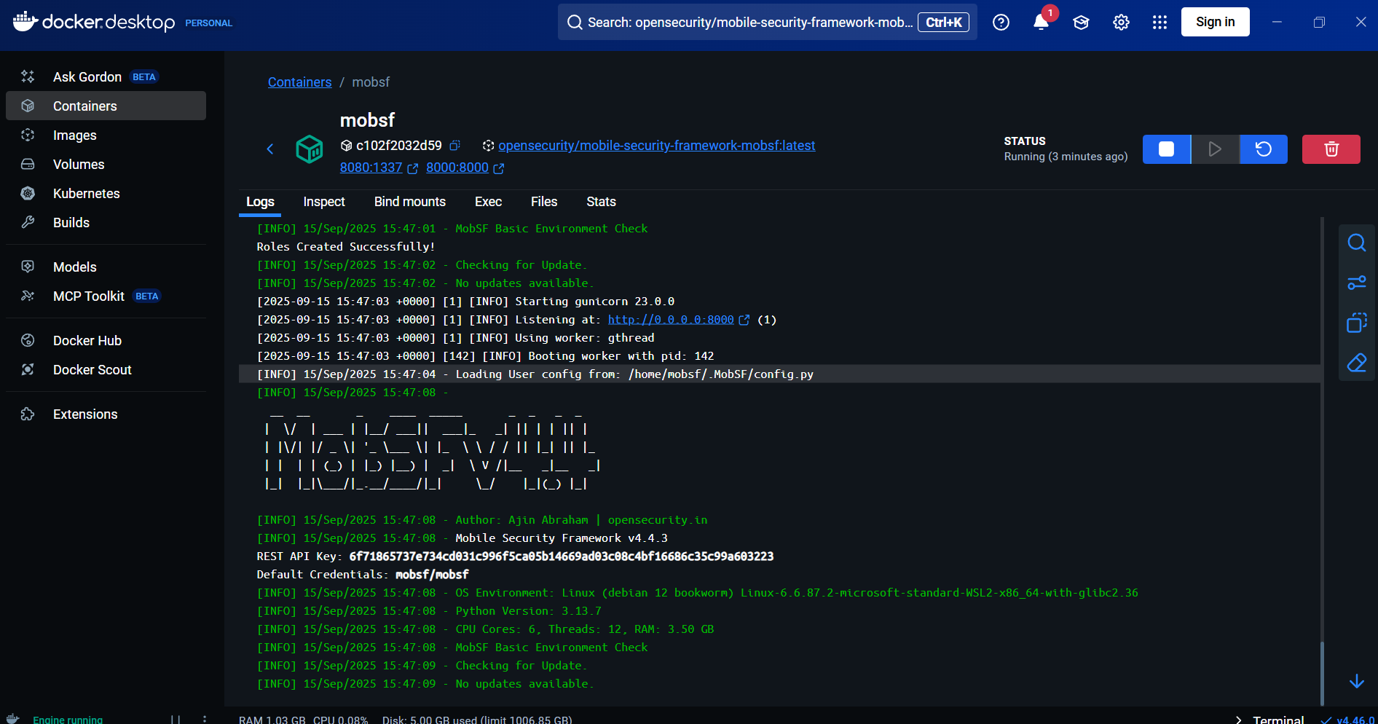
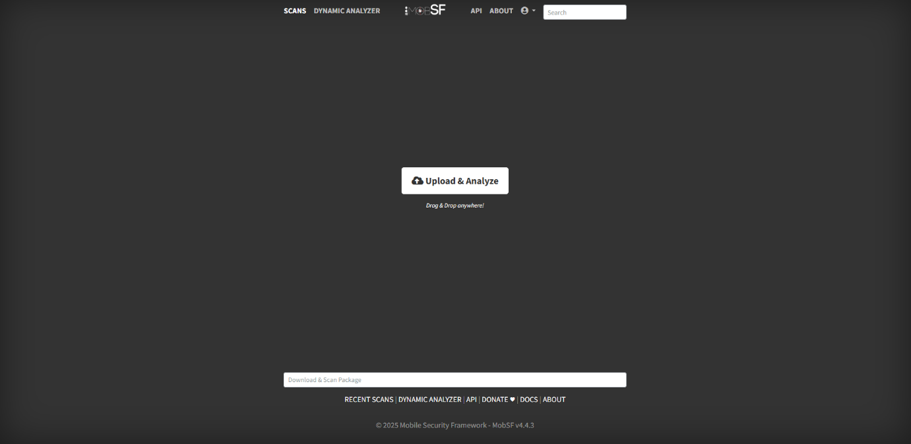

MobSF Analysis:
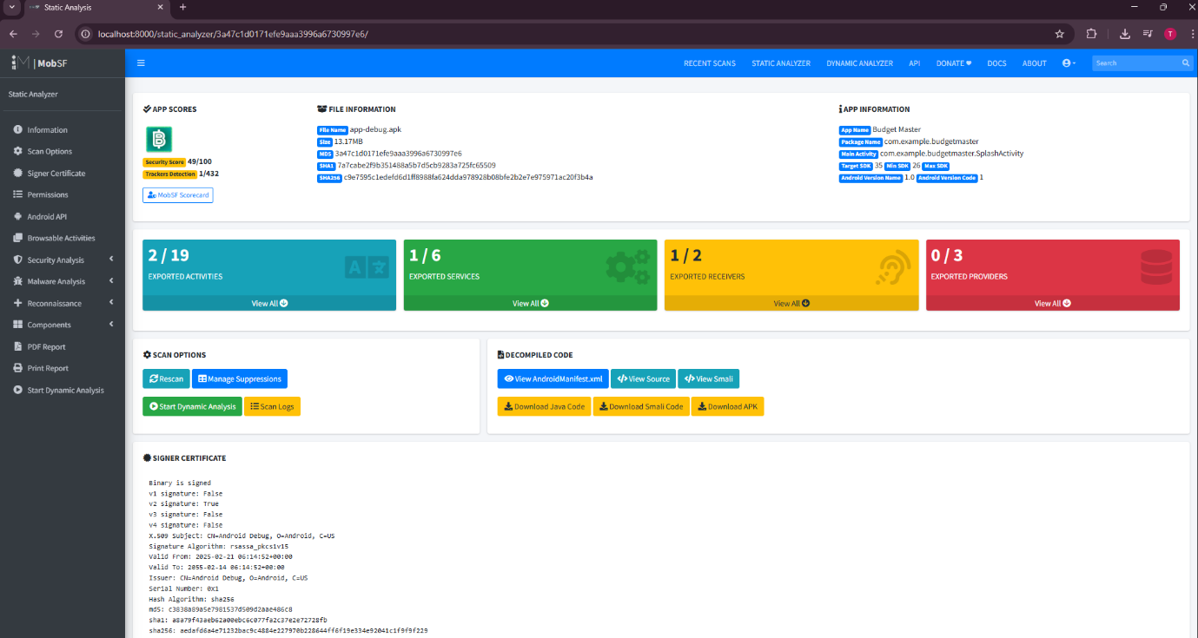

AWS CLI Download:
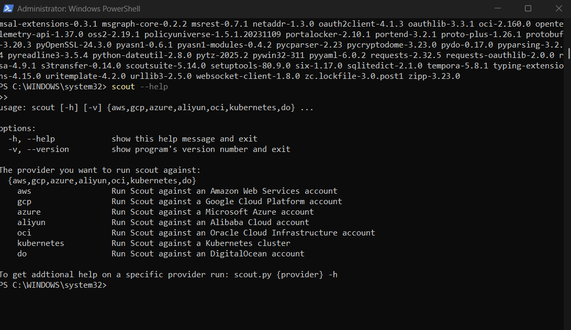

ScoutSuite AWS Security Analysis Write Up

Introduction
In order to evaluate the security posture of the provided AWS environment, ScoutSuite was used to conduct an automated audit across key services including IAM, S3, EC2, RDS, VPC, and CloudTrail. The tool successfully authenticated using the supplied credentials and produced an HTML dashboard summarising potential risks by severity. While the account contained very few active resources, the report still highlighted important issues that would be relevant for organisational security considerations.

The summary dashboard displayed a small number of findings, with the majority linked to IAM and monitoring rather than deployed infrastructure. Under IAM, the only user present was “Dynamo”. ScoutSuite flagged that this account lacked multi-factor authentication (MFA), a significant weakness as it increases the risk of compromise if credentials are exposed. The report also noted that permissions could be overly permissive, a common misconfiguration in cloud environments that can escalate the impact of account takeover.

In addition to IAM concerns, ScoutSuite flagged CloudTrail as not enabled. This is a critical gap, as CloudTrail provides audit logging for user activity and API calls. Without it, malicious or accidental actions in the account may go undetected, undermining forensic and compliance efforts. No findings were reported for S3, EC2, or RDS because no resources existed in those services within the account. Errors reported for services like Direct Connect were expected, since the account does not have access to these premium offerings.

The overall experience demonstrates the strengths of ScoutSuite. It provided a clear overview of the account’s security state, categorised risks by severity, and highlighted best practice violations even in a minimal environment. At the same time, the report illustrates some limitations. ScoutSuite is a read-only tool, so it does not remediate issues, and it produces warnings for services that may not be in use. Nevertheless, these are minor considerations compared to the value it offers as an automated auditing tool.

Conclusion
In conclusion, this exercise confirmed that ScoutSuite can effectively identify configuration weaknesses in AWS environments. Even in a limited account, it flagged meaningful issues such as missing MFA and disabled CloudTrail logging, both of which are high-priority concerns. These findings support the adoption of ScoutSuite as part of the organisation’s cloud security toolkit. When combined with monitoring tools and manual reviews, ScoutSuite can strengthen governance and provide assurance that AWS deployments are aligned with security best practices.
AWS Dashboard:
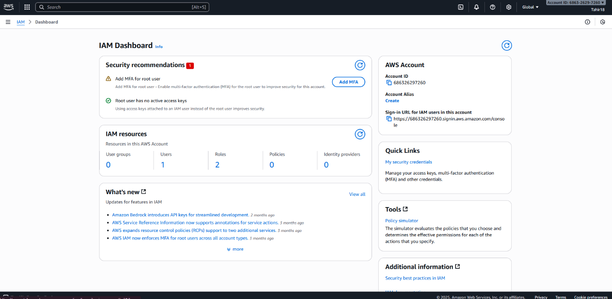

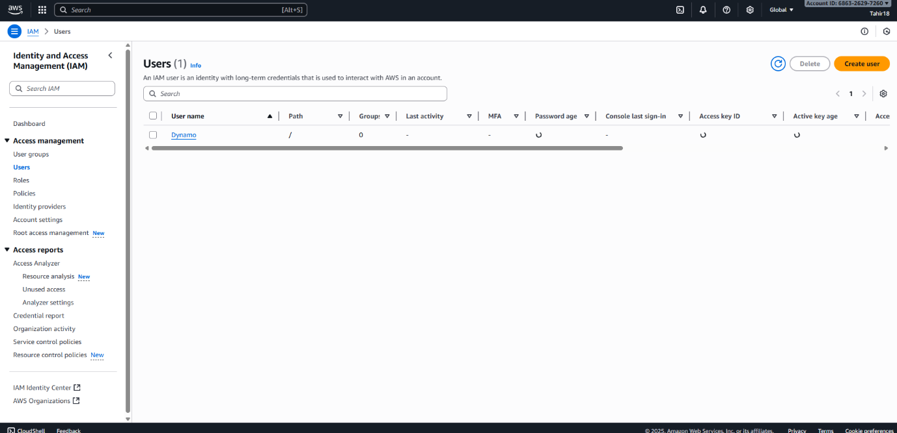
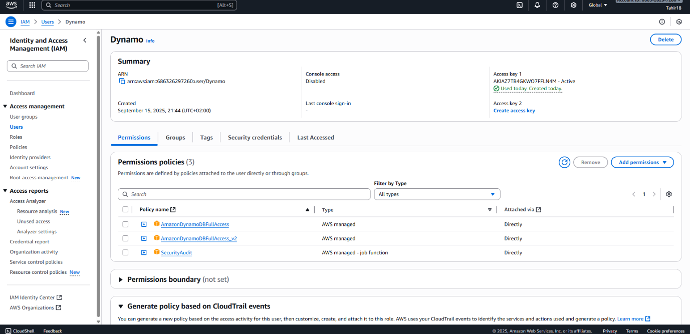
ScoutSuite Analysis Dashboard:
